Handwritten Balinesse Character Recognition using K-Nearest Neighbor

¹I Wayan Agus Surya Darma, ²Ni Kadek Ariasih

STMIK STIKOM Indonesia
Tukad Pakerisan 97th Street
Denpasar, Bali, Indonesia
¹surya@stiki-indonesia.ac.id, ²dekarik96@gmail.com

Abstract

Balinese character recognition is a technique to recognize feature or pattern of Balinese character. Feature of Balinese character is generated through feature extraction process. This research using handwritten Balinese character. Feature extraction is a process to obtain the feature of character. In this research, feature extraction process generated semantic and direction feature of handwritten Balinese character. Recognition is using K-Nearest Neighbor algorithm to recognize 81 handwritten Balinese character. The feature of Balinese character images tester are compared with reference features. Result of the recognition system with K=3 and reference=10 is achieved a success rate of 97,53%.

Keywords: Balinese Character, Handwritten, Feature Extraction, K-Nearest Neighbor.

- Introduction
A culture that exists in every region is the inheritance of the ancestors who should be preserved. There are various cultural heritages in Bali that need to be considered because it has been marginalized because of the development of the times and the more advanced technology. Balinese script is a very common one because it contains the cultural values of the people in Bali. Balinese script is a character written by people in bali.
As technology develops, this Balinese script begins to be marginalized by modern books and more sophisticated equipment in recording and storing text that is certainly much more efficient. However a culture should be preserved and preserved to exist as a cultural heritage. This is what began to disappear from modern society, the less people who are interested in Balinese script do not even know the character of Balinese script. Balinese script is usually written on the leaves of Lontar to store certain information.

Understanding of Balinese script is indispensable in reading and writing Balinese script. Balinese script is a traditional Balinese script in Bali. This script is divided into several parts namely wianjana script (consonant) and voice script (vowel). Wianjana characters are 18 characters and voice characters are 6 characters. In addition to wianjana script and voice script, there are also pengangge-pengangge as component of writing Balinese script. This becomes an obstacle for modern society who has little understanding in reading Balinese script characters.

As an effort to preserve Balinese script, research on the introduction of Balinese script is done as an appreciation of the culture in Bali. Image processing process of a Balinese script through a process that starts from image acquisition, pre-processing, segmentation, feature extraction and introduction of Balinese script [1]. The acquisition process is a procedure to retrieve and acquire the image of Balinese script by using optical camera or scanner, so the image of Balinese script becomes digital form. The next process is pre-processing, which is the initial process that aims to improve and process the image of Balinesse character acquisition results so that the image quality becomes better in this case eliminates the noise so that Balinese script becomes cleaner in the sense that there is no noise [2]. The process of segmentation is to break the image of Balinese script per script so that new image with certain size is obtained. Furthermore, the result of segmentation through feature extraction process is the process to get the special characteristic of each Balinese character [3]. The results of feature extraction through the identification process is the process of recognition feature Balinese character so that can be recognized.

In this research, the image of Balinese character used as data source is Balinese script character. Balinese script character used is wianjana script which consist of 18 characters Balinese script. The special features or features resulting from each Balinese script character are the direction and semantic features based on the shape and pattern that each Balinese script character possesses. The introduction stage of Balinese script by using K-Nearest Neighbor method that utilizes the feature of semantic direction and features owned by Balinese script.

- Fundamental Theory

  - Feature Extraction
Feature extraction is used to find out the patterns or features of each character that the next process is done for character recognition. Broadly speaking a character has 3 characteristic that is:

- Character width and height
Size is taken from the average of each character entered as learning.
- Character Section
Character Section is the division of writing into three areas that is the top (ascender), the middle (main body) and the bottom (descender). Then each section is taken using the histogram to distinguish the characters.
- Stroke Modeling
Stroke modeling uses a series of strokes (lines of writing) to recognize characters. The series of strokes is a collection of dots that are labeled numbers based on the direction of the next neighbor point stored in the list which is then checked the pattern [4].

  - K-Nearest Neighbor
K-Nearest Neighbor (KNN) is an interesting method of classification in data mining which is often referred to as lazy learning. K-Nearest Neighbor (KNN) is included in instance-based learning where the training data set is stored so that the classification for new data that has not been classified can be classified by comparing the data that is most similar to the training set with the nearest neighbor concept. A neighbor is considered nearest if it has the smallest distance. K nearest neighbor keeps all the training examples and puts off learning until new data has to be classified, this is why it's called lazy learning [5].

The KNN implementation works based on the shortest distance from the instance query to the sample data to determine its k nearest neighbor [6]. The sample data is projected into many-dimensional space, where each dimension represents a feature of the data. This space is divided into sections based on the classification of sample data. A point in this space is marked by class c if class c is the most common classification of the nearest neighbor of the point. Calculate the distance between the new data and the training set so that the distance obtained by the neighbor distance.
Steps to calculate K-Nearest Neighbor method:
- Determine the parameter K (the number of nearest neighbors).
- Calculate the quadratic distance of euclidean (query instance) of each object against the given sample data.
- Then sort the objects into groups that have the smallest distance.
- Collect category Y (nearest neighbor classification).
sing the nearest neighbor category of the majority, it can be predicted the value of the query instance that has been calculated.

  - Balinesse Character
The history of the Balinese script is closely related to the development of the script in India. Balinese script comes from the language and script brought from India when the era of spreading Hinduism and Buddhism to Indonesia. Originally in India there is an alphabet called Karosti script. From this script Karosti then developed into Brahmi script. Brahmi script then developed again to some countries in Southeast Asia and South Asia.
The number of Balinese Wianjana script limited to ha, na, ca, ra, ka, da, ta, sa, wa, la, ma, ga, ba, nga, pa, ja, yes, while the Balinese language continues to grow based on research on lontar or inscription which consists of the ancient Javanese language and Sanskrit, then thus Balinese script can be grouped based on the pronunciation called citizens of letters. In Balinese language, citizen means type / group and script means letter / symbol of writing ", not writing system.

Fig. 1 Wianjana Balinesse Character

- Methodology

This research started from extraction process of Balinese script character feature to get special character from each character of Balinese script. The resulting feature on feature extraction process from Balinese script image is the direction and semantic feature. Based on the characteristic and semantic features of Balinese script, Balinese script feature is used in the introduction phase of Balinese script. The following is an overview of the Balinese script recognition system in this study.
Fig. 2 An overview of the Balinese character recognition
  - Image Acquisition
Stages of recognition of the script starts from the Image Acquisition process with the input image of Balinese script script character. Balinese script handwriting used is Wianjana script. The Wianjana script consists of 18 characters that will be used for training data as a reference in the introduction process.

  - Feature Extraction
The feature extraction stage is the stage to get feature in the form of special characteristic possessed by Balinese script character. This feature will be used as training data on Balinese script character recognition process. There are two types of Balinese script feature that will be generated at the feature extraction stage, which is the direction feature and the semantic feature.

    - Direction Feature
The Direction feature is used to detect a stroke of a character by providing a feature value based on the direction label of a pixel. The direction orientation of a stroke plays an important role in distinguishing the various characters of the Balinese script. In an image consisting of n × n pixels, pixels containing white are given a value of 0 whereas the pixels that are black and form a character will be replaced with corresponding direction values.

Table I
Nilai Label dan Arah pada Fitur Arah
Bentuk | Nilai | Arah
 | 2 | Vertikal
 | 4 | Horizontal
 | 3 | Diagonal Kanan
 | 5 | Diagonal Kiri

The determination of the direction values of Balinese characters is required as follows:

- Specifies the starting point of the character
The character's starting point is the first pixel found in the lower left and most character image. The new starting point is any pixel that has different directions from the previous row segment. The iteration of the starting point and direction search starts from the first starting point until there are no longer character-forming pixels that have no directional values yet. All starting points found will be replaced with a value of 8 for a while. This value 8 will then be normalized in the subsequent process after all the starting points are found and other pixels other than the starting points have a direction value.
- Normalization of Direction Value
This process is done to change the value 8 which is a temporary value for the starting point. There are two steps to this process. The first step is to find the largest possible frequency of occurrence of a direction on a line segment starting at a starting point. The second step is to use the direction value with the largest frequency of occurrence is to replace the value 8 at the starting point.

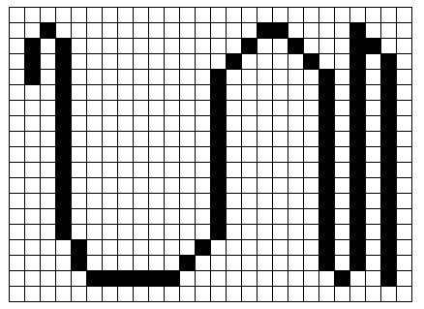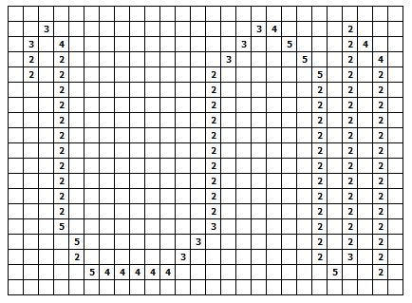
- (b)
Fig. 3 The process of forming values (a) images of Balinese characters (b) the result of assigning the value of each vector
The direction feature that has been successfully extracted on a Balinese script character is made up of a 16x1 size matrix containing the features of the vertical Number on the top left, the right diagonal on the top left, the horizontal on the top left, the left diagonal on the top left, the top right vertical, the diagonal right at top right, horizontal at top right, left diagonal at top right, vertical at bottom left, right diagonal at left bottom, horizontal at left bottom, left diagonal at bottom left, vertical at bottom right, right diagonal at bottom right, horizontal on the bottom right, the left diagonal on the bottom right. The following is a feature of the direction generated on Balinese script.

Fig. 4 Direction Feature

    - Semantic Feature
Features information about Balinese script characters can also be viewed using semantic features. Semantic features are used to look for semantic characteristics of Balinese characters such as number of black strokes, loops, endpoints, character lengths, character widths and openings of characters. From the pixels formed to a vector, it can be seen that the stroke of the pixel will form an image of the Balinese script character [7].

The extraction process of semantic features produces a feature data presented in the form of a new matrix of 12x1 which contains semantic features of the number of stop points, the number of stop points in the top left, bottom left, right and bottom right, the number of lines and columns, loop count, horizontal number, vertical number, number of vertical positions left and right for each character through feature extraction process. The semantic features are presented in the fig. 5.
Fig. 5 Semantic Feature
3.3 Classification
The classification stage is performed on data of Balinese script feature. Balinese script features will be classified so as to produce a model of training data that will be used in the introduction phase of Balinese script. At the introduction stage, Balinese script features will also be recognized through the classification process using the K-Nearest Neighbor method.
- Result and Analysis

  - System Overview
An overview of the Balinese script introduction to this study from the training phase, the feature extraction stage to the introduction phase is illustrated as shown in Fig. 6.
Fig. 6 System Overview
  - Recognition Process
The recognition phase of Balinese script begins with the data training process which will be used in the introduction stage of Akasara Bali.

    - Training Data
Training is an important stage in the process of character recognition, this stage will determine the results of the introduction of a character based on character features that have been trained at this stage. In this study, the amount of image data for each character script character Balinese used as training data can be determined to get the desired results. Below is the training data generated in the training process, with the amount of data used for each type of Balinese script character is 5 data.
The Direction features generated at the feature extraction process at the training phase on each of the 5 character images for each Wianjana script character consisting of 18 Balinese script, with the number of Direction character features are 16 features. So the total number of semantic features generated is = 90 x 16 features.
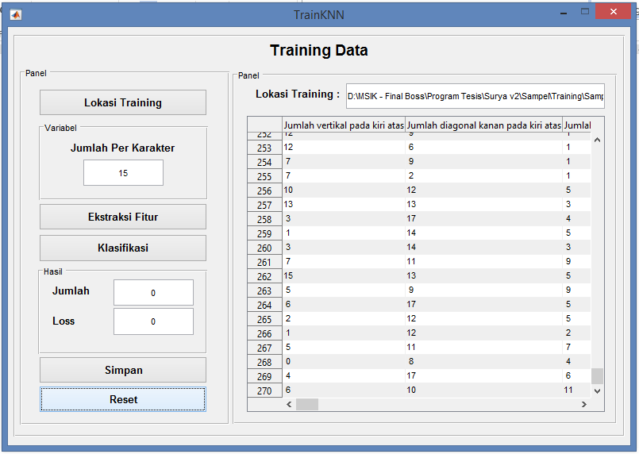
Fig. 7 Training Process

    - Recognition Process
The introduction stage begins with the selection of the imagery image to be recognized. The Balinese image that has been inserted into the system will be transformed into an image of a pixel size.
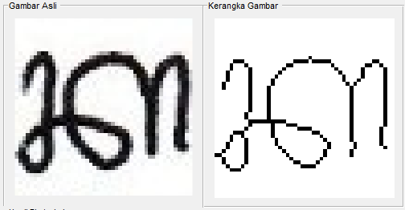
Fig. 8 Balinesse Character Image Converted into one pixel image

The process is continued by performing feature extraction on the skeleton framework so as to obtain the value of the direction and semantic features. Below this will be a feature extraction stage on Balinese script character "Ka". The first feature extraction is performed on Balinese script character "Ka (1)" which results in Balinese script feature.
Fig. 9 Balinesse Character Feature

Features obtained on the Balinese script "Ka" based on the feature direction and semantic features contained in the Balinese script, the following is a visualization of the features contained in the Balinese script "Ka" which can be seen in fig. 10.
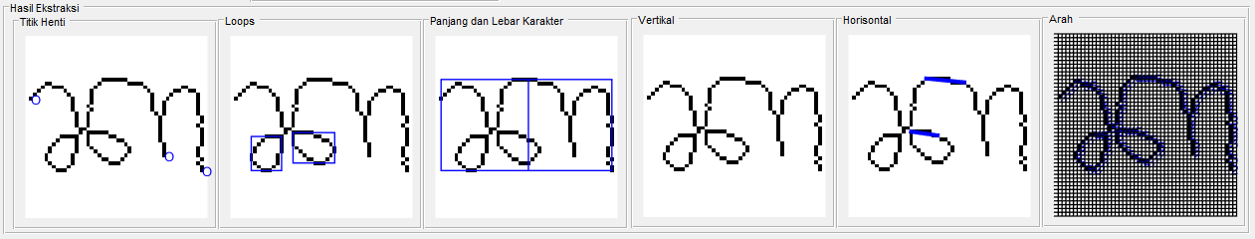
Fig. 10 Visualisasi The Result of Balinesse character“Ka”.

The next process is the classification, which begins by selecting the model of training data that has been made in the training process data. The model of training data used may vary according to the amount of Balinese script data used for each character, as described earlier in the data training phase. Before performing the classification process, it is necessary to determine the value of K, to determine the number of ketetanggan in the classification process. The magnitude of K value will affect the results of the introduction of Balinese script. Here are some of the Balinese script character recognition results presented in the fig. 11.
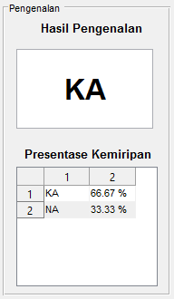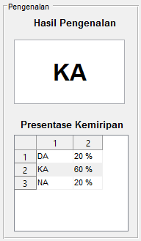
Fig. 11 The recognition result of k=3 and The recognition result of k=5

System test is done to know the performance of Balinese script recognition system and to know the success rate of this research. Based on the tests that have been done, using varying number of references, the results of various recognition accuracy are obtained. The following is a graph of the results of the introduction by using the reference number 5, 7 and 10 presented in Fig. 12.

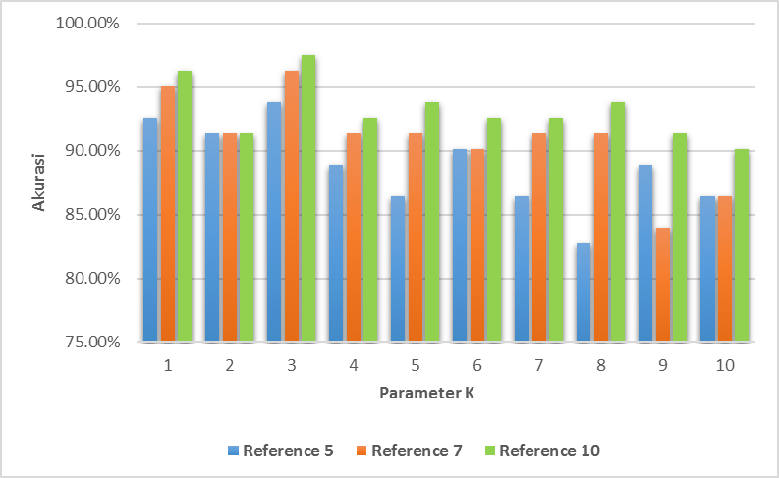
Fig.12 Comparison Percentage Of Recognition Based On Number Of References Used

The results are strongly influenced by the parameter K and the number of references used in the introduction stage. Fig. 12 shows the highest accuracy produced by the test using the parameter K = 3 and reference = 10.
Here is the percentage graph of the test results on the parameter K used in each test with a reference count of 10 for each Balinese script character. Based on the test results by testing the parameters K = 1 to K = 10 shows the highest percentage obtained in the test using parameter K = 3 presented in Fig. 13.
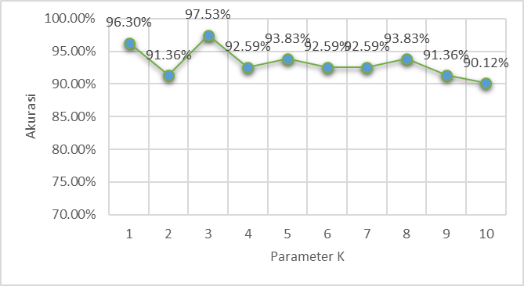
Fig. 13 Percentage of Recognition Result based on K and Reference parameters = 10

- Conclusion

Based on the results of the research of the system test that has been discussed in the previous chapter, this research concludes that the features of the direction and semantic features are obtained in Balinese script based on the special characteristics possessed by each character of Balinese script. Based on the results of the introduction of Balinese script that has been done by using the feature direction and semantic features owned by the Balinese script show good results seen based on the percentage of introduction generated by 97.53%. The features and direction of semantic features produced by Balinese script characters vary, this is because Balinese script is handwritten. The recognition performance using the K Nearest Neighbor (KNN) method is influenced by the parameter K and the amount of training data (reference) used. Based on the tests that have been done, it can be concluded in this study, the performance of the system with KNN method with the accuracy of introduction in handwritten script Handwritten for 97.53% by using parameter K = 3 and reference = 10.

References
[1] M. Sudarma and N. P. Sutramiani, “The Thinning Zhang-Suen Application Method in the Image of Balinese Scripts on the Papyrus,” vol. 91, no. 1, pp. 9–13, 2014.
[2] N. P. Sutramiani, D. Putra, and M. Sudarma, “Local Adaptive Thresholding Pada Preprocessing Citra Lontar Aksara Bali,” vol. 14, no. 1, pp. 27–30, 2015.
[3] D. Putra, Pengolahan Citra Digital. Yogyakarta: Andi, 2010.
[4] S. Darma, D. Putra, and M. Sudarma, “Ekstraksi Fitur Aksara Bali Menggunakan Metode Zoning,” vol. 14, no. 2, pp. 44–49, 2015.
[5] W. Ginantra, “Deteksi Batik Parang Menggunakan Fitur Co-Occurrence Matrix dan Geometric Moment Invariant dengan Klasifikasi KNN,” Lontar Komput., vol. 7, no. 1, pp. 715–725, 2016.
[6] M. Rashad and N. Semary, “Isolated Printed Arabic Character Recognition Using KNN and Random Forest Tree Classifiers,” Adv. Mach. Learn. Technol. Appl., vol. 488, pp. 11–17, 2014.
[7] M. Sudarma and S. Darma, “The Identification of Balinese Scripts Characters based on Semantic Feature and K Nearest Neighbor,” Int. J. Comput. Appl., vol. 91, no. 1, pp. 14–18, Apr. 2014.

